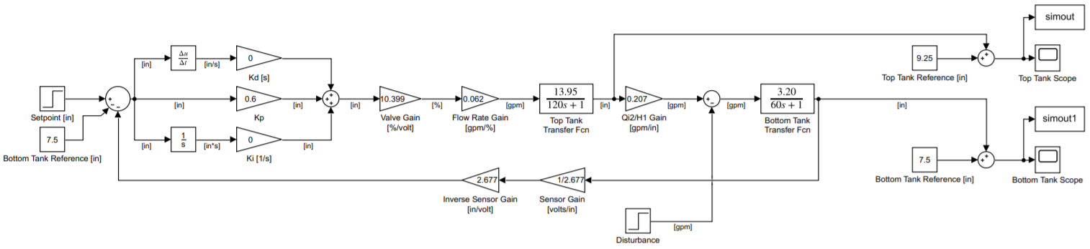

**Figure 7:** P-Only Controller Simulink Model

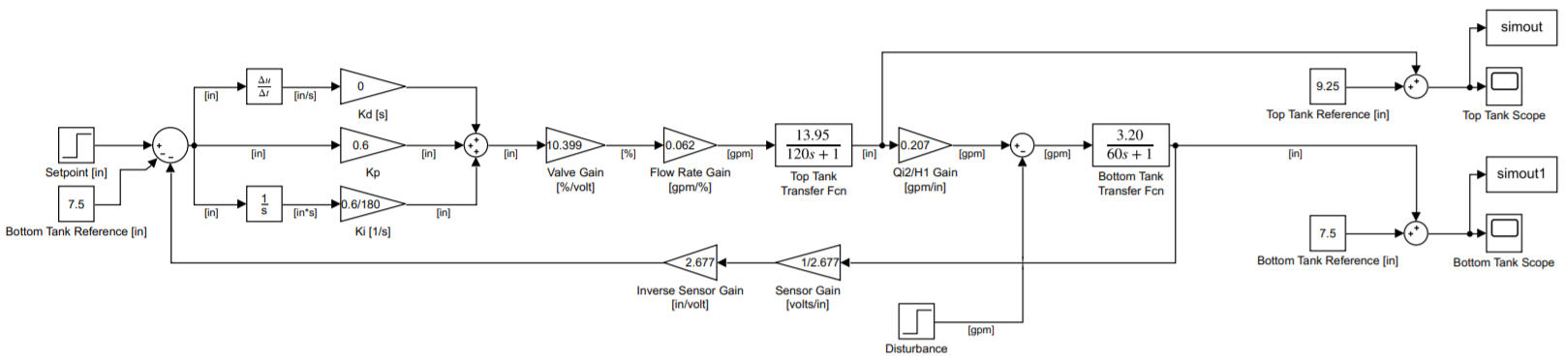

**Figure 8:** PI Controller Simulink Model

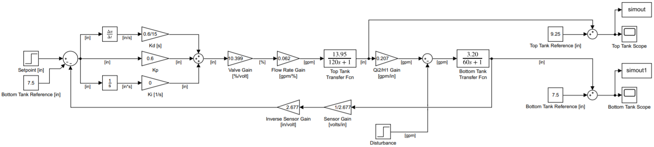

**Figure 9:** PD Controller Simulink Model